REMEMBRANCE
This morning, during an additional assembly about Remembrance, we held a 1-minute silence at 11am as an act of remembrance and out of respect for the many men and women who have risked or lost their lives and in some cases suffered significant injuries in service to our country and to protect the freedoms we all enjoy as a result. We particularly remembered those who fought in the First or Second World Wars and in more recent conflicts and took a moment to consider the devastating impact that war has on all of those in conflict. Remembrance was further explored across the school in different ways in class. Below are some the poppies made by Beech Class and the Forest School group today.

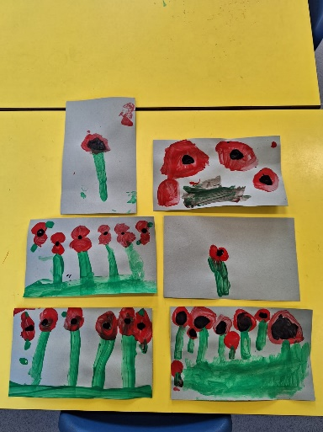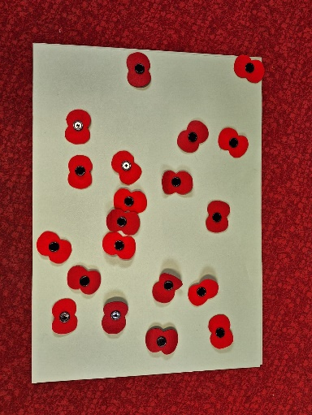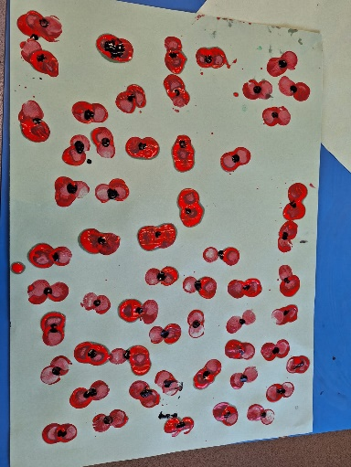

SAFETY MESSAGES
Parents of children in Year 5 and 6 that walk to and from school on their own please can you talk to your children about what to do if they arrive at school late and the gates have been locked. If this does happen, then they should come straight to the school office and they will be let in by the office staff. Similarly, please talk to your child about what to do if they get home and cannot get into the house.

Please can I also remind all parents that drive to and from school to be mindful that school drop-off and pick up are very busy times, with lots of children and parents around Laburnum Road. We have had a few issues raised recently where parents have parked dangerously or driven in a way that has scared other road users and pedestrians, including on the private part of Laburnum Road. Please can I also remind parents that the private road should not be used for dropping children off, picking them up or parking as this part of the road is owned and maintained by the residents and not the council.

STAFFING UPDATE – MRS BOYALL
With immediate effect, Mrs Boyall, our school SENDCo and a Deputy Designated Safeguarding Lead, has reduced her time in school to 1.5 days a week and will only be in school as SENDCo on a Tuesday, Wednesday and Thursday morning. This will mean some rescheduling of planned meetings, or meetings being with myself or Mrs Dawes instead.

From January 1st 2024, Mrs Boyall will be taking a complete leave of absence from her role as SENDCo at Laburnum until at least the end of the academic year in order that she can dedicate her time and attention to the needs of her and her husband, who very sadly has a terminal condition. I know that all of you will join me in sending Mrs Boyall our best wishes at this challenging time.

We are in the process of making arrangements to cover Mrs Boyall’s absence and will update you on this in the near future. In the meantime, please direct any SEND related queries to class teachers in the first instance and then to myself or Mrs Dawes. Safeguarding concerns can be raised with me as Designated Safeguarding Lead (DSL) and Mrs Dawes as Deputy DSL.

ANTI-BULLYING WEEK
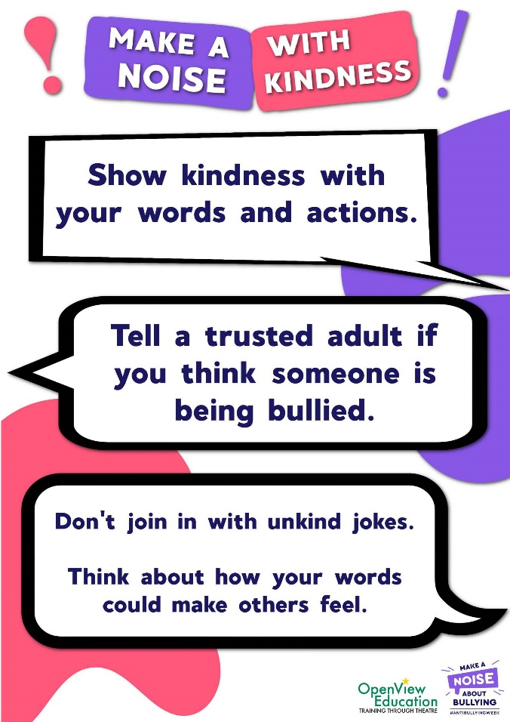
Next week is national anti-bullying week. We teach key messages about tolerance, respect and kindness all year, alongside a clear message that discrimination and bullying will not be tolerated at Laburnum. Next week, we will be emphasising these key points all week.

The them this year is ‘make a noise about bullying’, with the key message being to speak out if you think someone is being bullied. The definition of bullying used in school is: “behaviour by an individual or a group, repeated over time that intentionally hurts another individual either physically or emotionally”. (DfE “Preventing and Tackling Bullying”, July 2017). This should not be confused with occasional unkindness or falling out with a friend. We emphasise this important distinction because we often have disagreements between children presented as ‘bullying.’ The danger is that incorrect overuse of the term undermines the importance of the messages we are giving when we talk about bullying and the impact it can have on both victims and perpetrators.

To mark the week and celebrate diversity and individuality, the nation is being encouraged to hold an odd socks day. At Laburnum, we are inviting all children to wear odd socks, colourful socks, patterned socks or socks that make you smile, for the whole week – show your personality through the socks that you wear and if you prefer the usual grey socks with your uniform, then that is fine too!

CHILDREN IN NEED
Friday 17th November is the annual BBC Children in Need day. All members of the school community are invited to come to school in non-school uniform for the day in exchange for a donation (whatever you can afford) to Children in Need.

AWARDS AND CELEBRATIONS WEEK ENDING 10th November 2023
ATTENDANCE TARGET 97% |  |  |  |  | THE GOLDEN MILE
Beech 96.3% 1 late mark  Elm 95.9% 0 late marks  Cedar 97.4% 1 late mark  Chestnut 96.0% 0 late marks  Willow 98.3% 1 late mark  Sycamore 97.3% 1 late mark  Oak 93.8% 1 late mark |  |  |  |  | This week the Golden Mile trophies were awarded to:  EYFS & KS1 KS2  Elm Sycamore
HOUSE POINTS THIS WEEK
228 | 248 |  |  |  | 255 |  |  | 245
WEEKLY CLASS C.A.R.E.S AWARD CERTIFICATES
CHALLENGE · ACHIEVE · RESPECT · EFFORT · SAFE
APPLE |  | BEECH |  | ELM |  |  | CEDAR
C - Chester  A - Amelia  R - Theodore  E - Hutton  S - Freddie  CARES - Tim-Elliot |  | C - Valentina  A - Zachary  R - Nicole  E - Tanner  S - Daniella  CARES - Luna |  | C - Sienna  A - Leo  R - Bart  E - Mason  S - Brody  CARES - Gabriela |  |  | C - Edith  A - Vinnie  R - Leo  E - Blake  S - Teddy  CARES - Skyla & Phoenix
CHESTNUT |  | WILLOW |  | SYCAMORE |  |  | OAK
C - Grace  A - George  R - Sophia  E - Leo  S - Emma-Leigh  CARES - Alex |  | C - Lottie  A - Akira  R - Meredith  E - James  S - Becky  CARES - Lana |  | C - Rudy  A - Milo  R - Evie  E - Roman  S - Kian  CARES - Rory |  |  | C - Wayne  A - Logan  R - Andrea  E - Regina  S - Charlie  CARES - Ella-Mae
WHOLE SCHOOL CARES AWARD  Year 5  Sycamore Class  10th November |  |  | WHOLE SCHOOL LUNCHTIME AWARD  Year 6  Oak Class  10th November October |  |  | 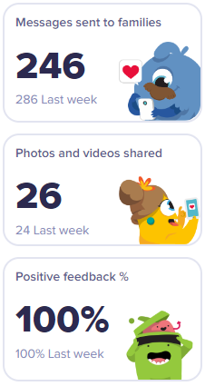

November
Mon 13th – Fri 17th |  | Anti-Bullying Week
Friday 17th | All Day | Children in Need 2022
Tuesday 21st | 10:00-11:00am | Nursery ‘stay and play’ session (January admission children/parents by invite) | Apple Classroom
Thursday 23rd | 1:30-2:30pm | Nursery ‘stay and play’ session (January admission children/parents by invite) | Apple Classroom
December
Thursday 7th | 9.25am-3.15pm | Nursery & Reception visit Herrings Green Farm | Wilstead, Beds
Wednesday 13th | 9:30am  2:30pm | Reception Christmas Production  Reception Christmas Production | School Hall  School Hall
Friday 15th | 12.00pm | Y1 & Y2 Pantomime , Milton Keynes Theatre
Monday 18th | 4:00pm | Whole School Carols on the Playground | Playground
Tuesday 19th |  | School Closes for Christmas Break
January
Thursday 4th |  | School Opens for Spring Term: Reception-Y6 Pupils return to school  Nursery 1:1 New Parent & Child Meetings
Friday 6th |  | Nursery Pupils return to school
Friday 19th | All Day | Y6 Young Voices | The O2 Arena, London
Friday 26th | All Day | Y3 & Y4 Bikeability Level 1
February
Friday 9th | All day | CHUMS Shine Bright, Wear Bright
Monday 5th | 9-10:00am | Oak (Y6) Class Parent Lesson Drop-in | Oak Classroom
Tuesday 6th | 9-10:00am | Cedar (Y2) Class Parent Lesson Drop-in  Sycamore (Y5) Class Parent Lesson Drop-in | Cedar Classroom  Sycamore Classroom
Wednesday 7th | 9-10:00am | Elm (Y1) Class Parent Lesson Drop-in  Chestnut (Y3) Class Parent Lesson Drop-in | Elm Classroom  Chestnut Classroom
Thursday 8th | 9-10:00am | Apple (N) Class Parent Session Drop-in  Beech (YR) Class Parent Lesson Drop-in | Apple Classroom  Beech Classroom
Friday 9th | 9-10:00am | Willow (Y4) Class Parent Lesson Drop-in | Willow Classroom
Monday 12th | 3:00-3:30pm | Pupil books available for Parents/Children to view together (books also available for in-school Parent/Teacher Meetings) | Classrooms
Tuesday 13th |  | Parent/Teacher Meetings | Virtual and in-school appointments available
Thursday 15th |  | Parent/Teacher Meetings
Friday 16th |  | School closes for half term break
Monday 26th |  | School opens for Spring 2
March
Thursday 7th |  | World Book Day
Tuesday 12th | 10:00-11:00am | Nursery ‘stay and play’ session (April admission children/parents by invite) | Apple Classroom
Thursday 14th | 1:30-2:30pm | Nursery ‘stay and play’ session (April admission children/parents by invite) | Apple Classroom
Friday 15th |  | Red Nose Day
Thursday 28th |  | School closes for Easter Break
April
Tuesday 16th |  | School Opens for Summer Term: Reception-Y6 Pupils return to school  Nursery 1:1 New Parent & Child Meetings
Wednesday 17th |  | Nursery Pupils return to school
Wednesday 17th – Friday 19th |  | Year 4 – Grafham Water Activity Centre
May
Monday 6th |  | May Day Bank Holiday: School Closed
Mon 13th-Thurs 16th |  | Year 6 Statutory Assessments (SATs)
Mon 20th |  | SCARF Life Education Visit to Laburnum
Friday 24th |  | School closes for half term break
June
Monday 3rd |  | School opens for Summer 2
Wednesday 5th |  | Yr 5/6 Faith Tour, Queens Park, Bedford
Mon 3rd – Fri 14th |  | Year 4 Multiplication Check window
Mon 10th – Fri 14th |  | Year 1 Phonics Screening Check week
Tuesday 25th | 10:00-11:00am | Nursery ‘stay and play’ session (September admission children/parents by invite) | Apple Classroom
Thursday 27th | 1:30-2:30pm | Nursery ‘stay and play’ session (September admission children/parents by invite) | Apple Classroom
July
Friday 12th |  | Annual Pupil Reports to Parents
Monday 15th |  | School Sports Day (Times to be confirmed)
Weds 17th - Thurs 18th |  | Class Transition Days (Children in new classes)
Friday 19th | 2:20pm | Year 6 Leavers Assembly  School closes for summer break

m

